CSIS 330 – Lab 1: Packet Tracer Network Representations

*[Adapted from Cisco Networking Academy Network Fundamentals]*

**Background:**

Packet Tracer (PT) is a network simulator that allows you to create a simulated network, configure the devices in the network, test the network, and examine the traffic in the network. The first step in creating a simulated network in Packet Tracer is to place the devices in the logical workplace and connect them together.

When Packet Tracer starts, it presents a logical view of the network in Realtime mode. The main part of the Packet Tracer interface is the Logical Workspace. This is the large blank area where devices can be placed and connected.

The lower left portion of the PT interface, below the yellow bar, is the portion of the interface that you use to select and place devices into the Logical Workplace. The first box in the lower left contains symbols that represent groups of devices. As you move the mouse pointer over these symbols, the name of the group appears in the text box in the center. When you click on one of these symbols, the specific devices in the group appear in the box to the right. As you point to the specific devices, a description of the device appears in the text box below the specific devices.

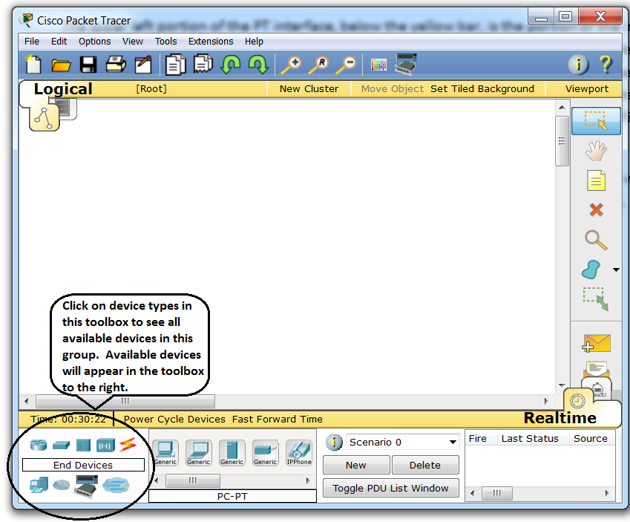

**Adding a Device or Connection:**

To add a device to the Logical Workplace, click on the specific device symbol in the center toolbox, point to where you want to place the device in the logical workplace (the pointer becomes a crosshair), and click. You can also drag and drop devices and connections from this toolbox into the Logical Workplace.

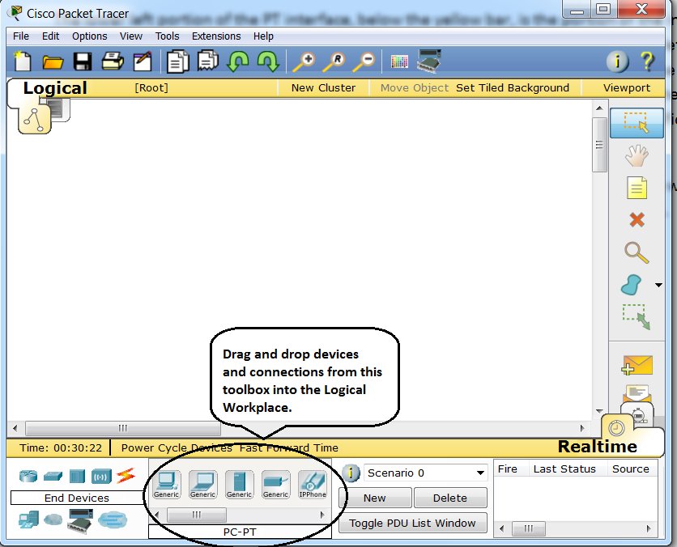

**Deleting a Device:**

To delete a device from the logical workplace, select the device by left-clicking on it and then click the “X” button on the toolbox that appears on the right-hand side of the screen.

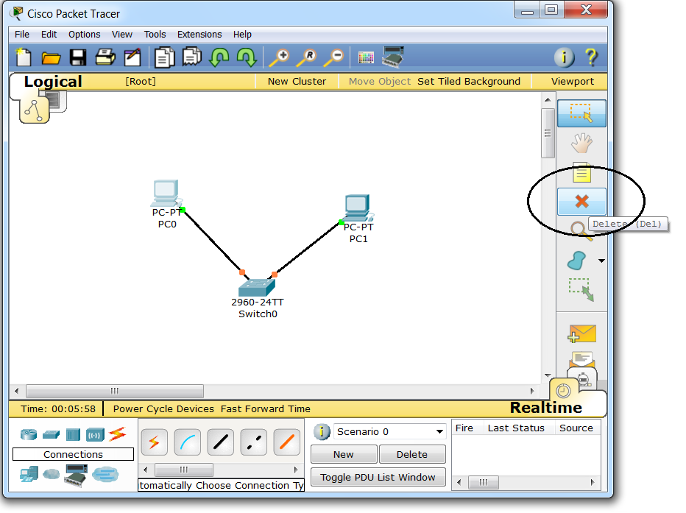

Note: When you click on the device to initially select it, a dialog box like the one below may appear.

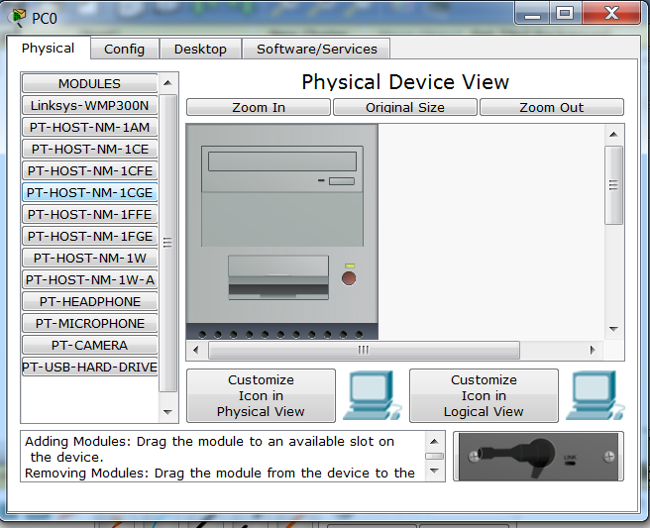

Close this dialog box and proceed to click the “X” (Delete) button on the toolbar. The pointer becomes an “X”, and you are prompted to delete the selected device. Click Yes.

After you click the “X” (Delete) button on the toolbar, you remain in Delete mode. That is, while in this mode, every subsequent device you click will be deleted. It is therefore important that after you perform a deletion, you click the Select button on the toolbar. This action takes you out of Delete mode. Pressing the [Esc] key also takes you out of Delete mode.

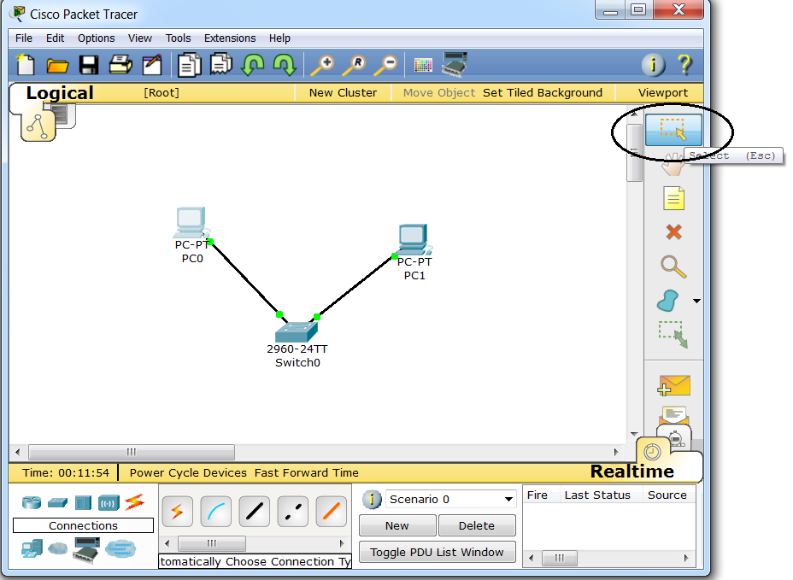

**Assignment Instructions:**

1. Locate and place the following five devices in a horizontal row across the Logical Workplace, with about an inch between them, in order from left to right:

* a server
* a 2960 switch
* an 1941 router
* a hub
* a PC

1. Change the Display Name for each device.

To change the display name for any device, single-click on the device in the Logical Workplace. This opens a dialog box that allows you to configure the device. On the Config tab of the dialog box, click on the Settings button below the Global button. If the Settings button is not displayed, click the Global button to expand the categories below it (Settings and Algorithm Settings).

In the Display Name textbox, the name of the device is already pre-filled for you with the name of the device, followed by a number. You must change the device name to **your first name**, **followed by an underscore**, followed by the device name and number that was pre-configured for you.

To exit the dialog box, click the “X” button in the upper right-hand corner. Your changes are automatically saved to your running configuration as soon as you enter them in a textbox.

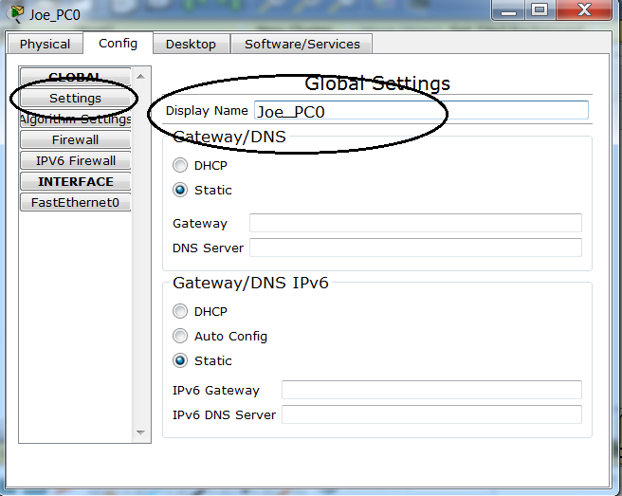

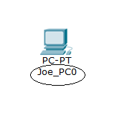

When you change the Display Name of a device, its new name is displayed below the device in the Logical Workplace.

1. Connect the devices using auto connect.

Click on the connections group symbol. The specific connection symbols provide different cable types that can be used to connect devices. The first specific type, the gold lightning bolt, will automatically select the connection type based on the interfaces available on the devices. When you click on this symbol, the pointer resembles a cable connector. To connect two devices, click the auto connection symbol, click the first device, and then click the second device. Starting with the server, connect each device to the device to its right using the auto connection symbol.

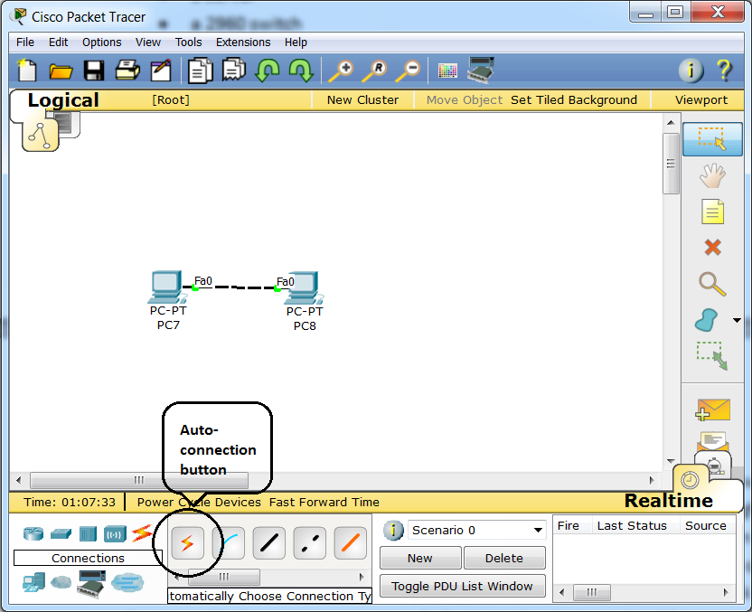

1. Save your configuration.

On the File menu, select Save. You will be prompted to save your configuration as a Packet Tracer Network file (*.pkt). The naming convention used in this class will be:

[your first initial + your last name] + “_Lab” (do not include the quotation marks) + the number of the lab]

For example, Joe Smith will save his file for Lab 1 using the filename “JSmith_Lab1”. Packet Tracer will automatically append the .pkt file extension to the file name if “Packet Tracer Network File” is selected from the “Save as type” dropdown list.

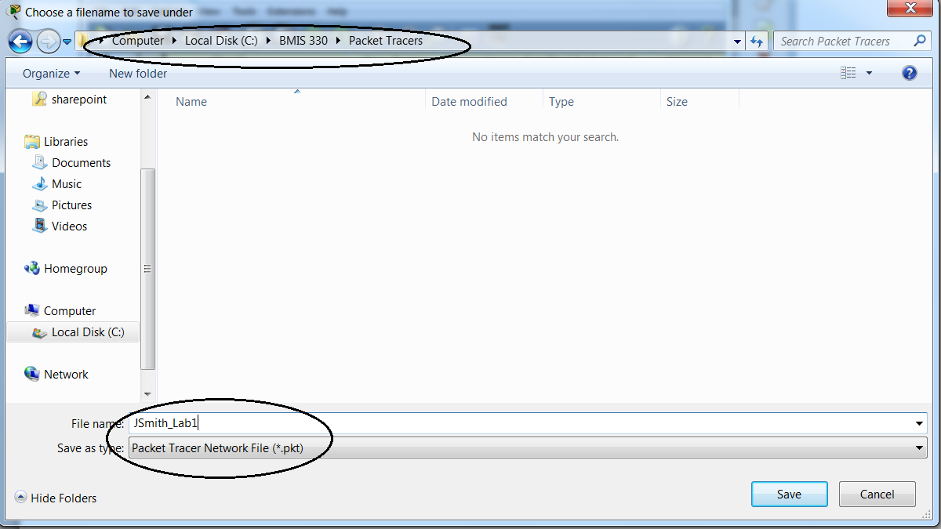

Note that when you exit Packet Tracer, you will likely be prompted to save your changes again (even if you have made no additional changes.) Click Yes to save changes again, and Packet Tracer will close.

To re-open an existing Packet Tracer file that you have created. You can double-click the file name in Windows Explorer. This will automatically launch Packet Tracer, and your PKT file will be opened. Alternately, you can launch Packet Tracer, select File | Open…, and navigate to the Packet Tracer File you want to open.

**Deliverables**:

Submit your assignment by attaching your PKT file to the appropriate assignment link in Blackboard.